Atoms into Molecules

Information  Bonds formed by sharing electrons are called covalent bonds. These nearly always form between non-metals.  It is the outer electrons of atoms that get involved in making chemical bonds in molecules. When non-metal atoms combine to form molecules, they do so by sharing electrons.  Take hydrogen as an example: each atom has one electron in its outer shell. The two hydrogen atoms combine to form a hydrogen molecule by sharing a pair of electrons. In this way both atoms end up with two electrons in the first shell. This is the electron arrangement of the inert gas helium.  A 'shared pair of electrons' links two atoms forming a covalent bond. The atoms are held together by the mutual attraction of both nuclei for the shared pair of electrons.  This second example shows the covalent bonding in water.  All molecules are held together by covalent bonds. There are also important materials with covalently bonded giant structures such as diamond and silica (silicon dioxide).  To do:  On the next page, draw diagrams to show the covalent bonding in these molecules:  - fluorine, F₂  - hydrogen fluoride, HF  - hydrogen sulphide H₂S  - tetrachloromethane, CCl₄ | 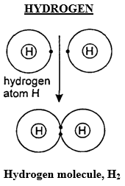
 | 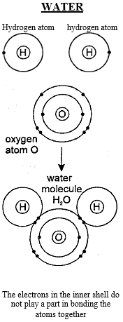

Key words: electron, bond, molecule, shell, covalent bond, sharing

Use this space to practise drawing dot and cross diagrams to show some different covalent molecules

